To: Dr. Helliwg
From: Kishor Simkhada
Date: Feb 26, 2019
Subject: Process Description: Personal Computer

Personal Computer:
Computer is an electronic device that takes inputs process it and displays the output to the user. In earlier time computer were used for the complex mathematical computation. They were specific based on the work that can be done on that device. Nowadays, computers are made to entertain human along with doing the complex work. It takes the input from user using mouse, keyboard, scanner, pen. Process it according to the need and the command provided by the user using the Processor and GPU. Finally, displays the result to user on Screen or the sheet of paper using printer.

Parts:
- Input(Keyboard and mouse)
- Process(CPU)
- Output(Monitor)
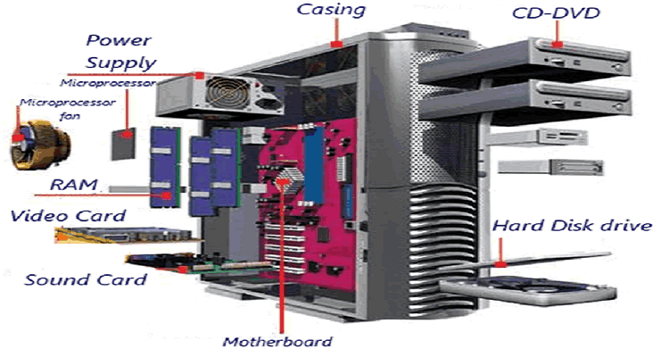
Process:
- Connect the CPU in the electricity source using special cable.
- The light on the CPU will glow.
- Press the power button.
- The light on your keyboard and mouse will glow.
- Provide any credential if needed to login to the system.
- Use Keyboard and mouse input
- Monitor will display the input as well as the output
- You can use the mouse to point the different things on the display.
- Do the desired work as needed
- Use the same power button to shut down or you can shut it down form the system.
Conclusion:
Computer are easy to use and can simplify your work. This device can be used to process, store, modify the information. This device can be found in different form like Laptop, Desktop, Tablet etc. There is portable version of the computer. It can be cheaper or expensive as your need.
There are quite a few proofreading errors, enough so that these suggest a language interference issue. Perhaps the Writing Center can help? Some of the verbs used suggest an instruction manual, which is not the assignment. See the comments in the margins. 70

